Group: bioluminescence

Members: Justin Cabral, Jonathan Duran, Humberto Martinez, Miles Gregg

Credentials:

* Corporate:
  + Username: corporate
  + Password: password

## GUI landing page:

* <http://cs509-group-project.s3-website-us-east-1.amazonaws.com/>

## Database storage tables:

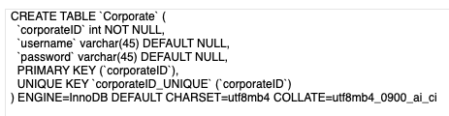

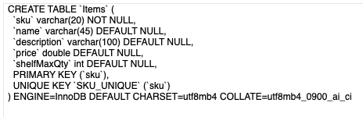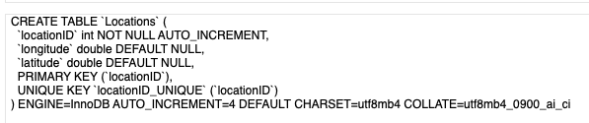

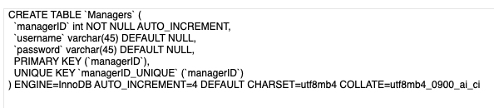

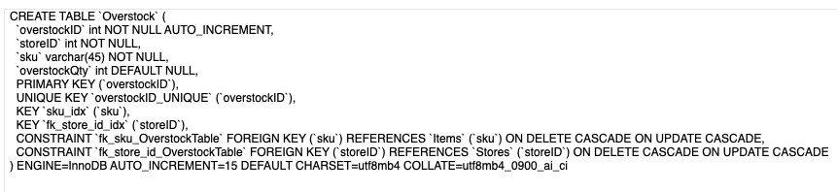

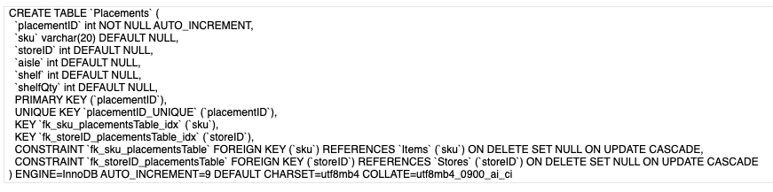

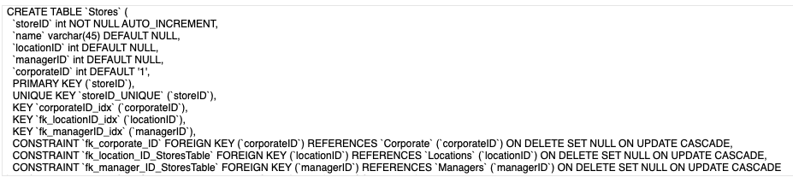

Git Commit Logs:

* <https://github.com/iJustinCabral/cloud_store/pulse>
* 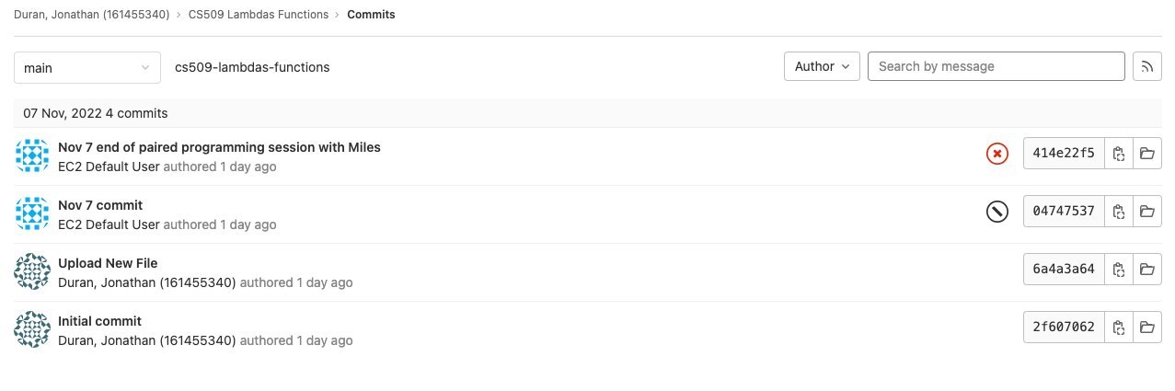

Trello Tasking Board

